25.62: a) 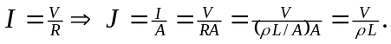 So to make the current density a maximum, we need the length between faces to be as small as possible, which means 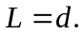 So the potential difference should be applied to those faces which are a distance apart. This maximum current density is 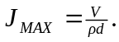

b) For a maximum current 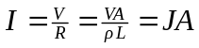 must be a maximum. The maximum area is presented by the faces that are a distance apart, and these two faces also have the greatest current density, so again, the potential should be placed over the faces a distance apart. This maximum current is
